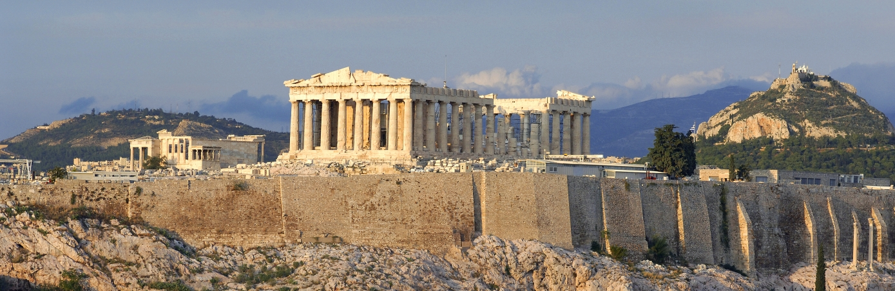
Oak Summer Term 2025 Mr. Pugh

MFL
This is France
That’s Tasty

Science
Earth and Space
Forces

Music
Using chords and structure
Identifying Important Musical Elements

English
Shared, group and silent reading
Spelling rules
Sentence construction and punctuation
Grammatical awareness
Drama
Speaking and listening skills

Fiction and poetry

Poetry appreciation
Fiction: settings and character development

Non-Fiction
All non-fiction writing will taught through topic work
Explanation writing
Debating/discussion skills
Design and Technology
Digital World: Monitoring Devices

Ancient Greece

Our topic for this term is life in ancient Greece and their influence. We will investigate: Which Greek words do we use today? How similar are our schools to the ones in ancient Greece? What did the ancient Greek great thinkers contribute to our knowledge of history, geography and other school subjects?
The majority of work covered this term will be linked to this topic.

Computing
Video Production
Sensing

Mathematics
Place value
Mental calculation: addition, subtraction, multiplication and division.
Written methods +/-/x/÷
Money and ‘real life’ problems
Problem solving
Fractions/Percentages/
Decimals
Ratio and proportion
Data handling
Measurement

P.E.

Athletics
Striking and Fielding games
P.E. and Games will be every Thursday and Friday afternoon.
P.E. kit should include T-shirt, shorts and daps or bare feet. Games kit should include trainers, hat and sun cream.
R.E.
For Christians, what kind of king is Jesus?
How does faith help people when life gets hard?

Art
Featured Artist: Yinka Shinobare, Judith Scott and Nicola Anthony
Sculpture, Greek Pots, Greek sculptures, Greek Gods.
P.S.H.E.
Drug education
Changes

